**is-a and has-a relationship**

In Java, there are two types of relationships between classes: **is-a and has-a.**

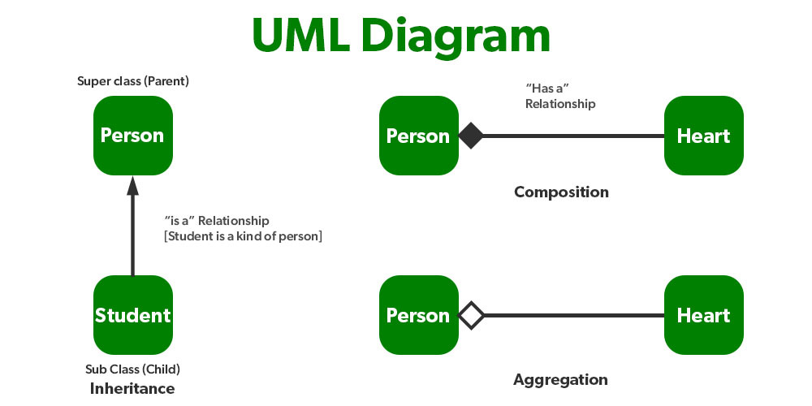

Is-a relationship, also known as inheritance, is when a class inherits from another class.

This means that the subclass inherits all of the properties and methods of the superclass.

For example, a Dog class might inherit from an Animal class.

This means that a Dog object would have all of the properties and methods of an Animal object, such as name, age, and eat().

Has-a relationship, also known as composition, is when a class contains an instance of another class as a field.

For example, a Dog class might have a Collar object as a field. This means that a Dog object would have a Collar object associated with it.

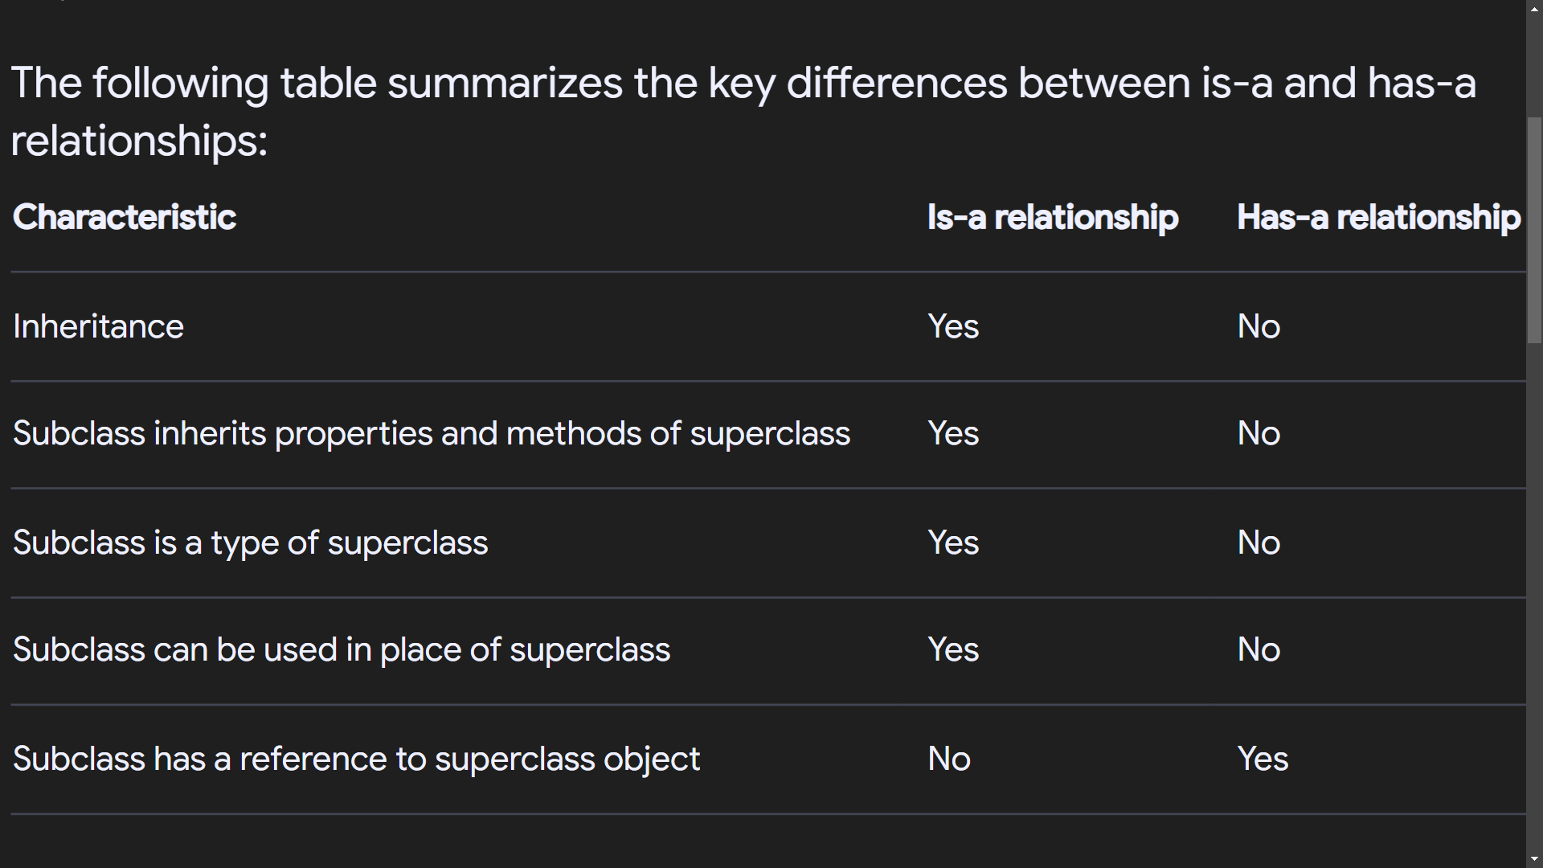

Is-a and has-a relationships are both important concepts in Java. They allow you to create complex and reusable code.